Nail Salon Appointment Booking Website

Shannon Kelly

COSC412

SPMP

SPMP Part 1: Introduction

* 1. Project Overview (description of project/summary)

A booking system will help the traffic of calls directly to a nail salon. The clients will be able to create account to view the available times they can coordinate with their own schedule to book themselves an appointment. They will enter what services they would like done and the site will return with the available times they can come in. The site will require the client to put their credit card information in when booking their appointment in case of a ‘No-show’ at the time of their appointment-but will not be charged until that happens. Any new clients will be required to make an account in order to obtain access to the schedule. From the outside, they will only be able to see basic information such as the location, phone number, services, and prices/descriptions of services. Overall, this site should help clients to find a time they prefer to get services done on their own rather than going back and forth calling the salon itself.

* 1. Project Deliverables (items w/ delivery dates/location)

The site should be directly for a nail salon and their clients and should be in business by May 2021.

* 1. Evolution of the Change (plans for any change)

Over time, the prices of services will change and the employees will be able to access the site and manually make any updates. The pictures will change due to new Instagram posts from the salon and the employees can select which pictures they would like shown. The site will “change constantly due to clients making or taking out appointments.

SPMP Part 3: Managerial Process

3.1 Management Objectives/Priorities (philosophy description and requirements vs schedule vs budget)

Philosophy: Each step of the process should be looked back on to avoid any errors along the way. Stick with basics and what is absolutely needed to function first. Extra steps can be added in later through the website creator.

Requirements: (Attached to Github)

Schedule: (Gantt chart attached to doc)

Budget: Wordpress subscription

3.2 Assumptions, Dependencies and Constraints (external events depended on/constraints)

Key features depended on are ‘wordpress’ features if allowed. Internal dependencies are the google maps for locating the place of business and accurate updates from the employees of pricing and other changes.

3.3 Risk Management (risk factors/tracking risks/contingency plans)

Risks: having no access to certain features of wordpress. Other option may include Square.

Adding any extra features along the way after the main features are completed.

Plan: Start with simply adding schedule for a nail tech in. Perfect main features/requirements with no error before any side features are added in. Make it client oriented with simple navigation.

SPMP Part 4: Technical Process

4.1 Methods, Tools, and Techniques

Tools: Wordpress, Github

Techniques: Design, implementing Instagram/google maps

WBS

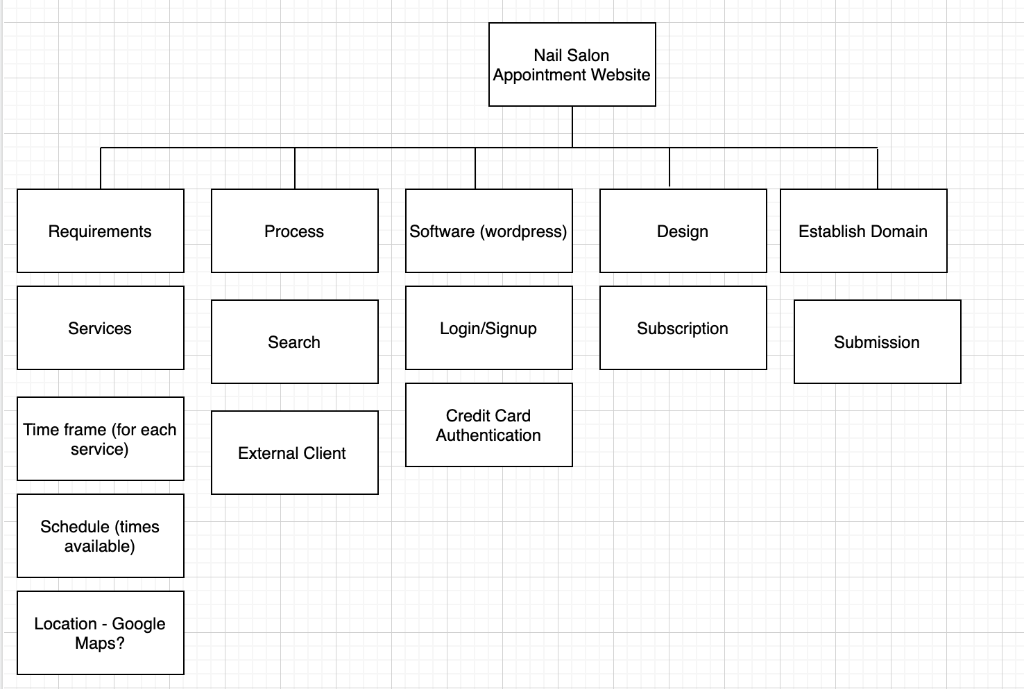

4.2 Software Documentation (Gantt Chart)

